PARTS NEEDED TO BE FIX
- DAPAT MAKA SORT/ or ma CLICK ANG AVAILABLE, LIMITED, AND FULL
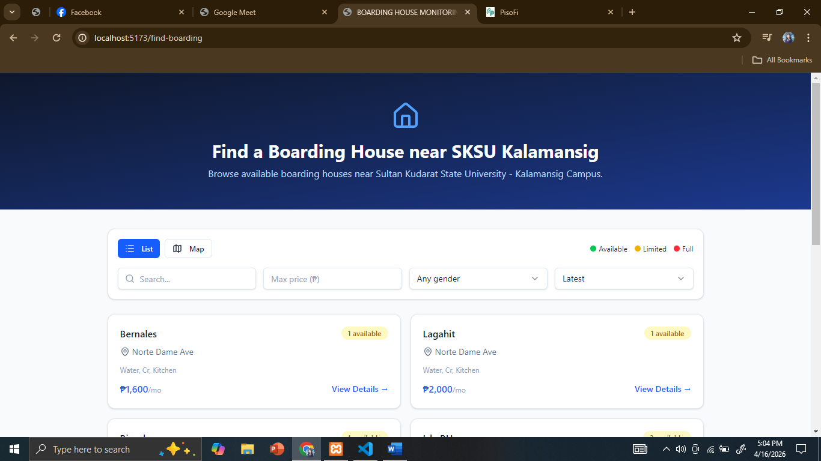
- Ang default map ay naka satellite
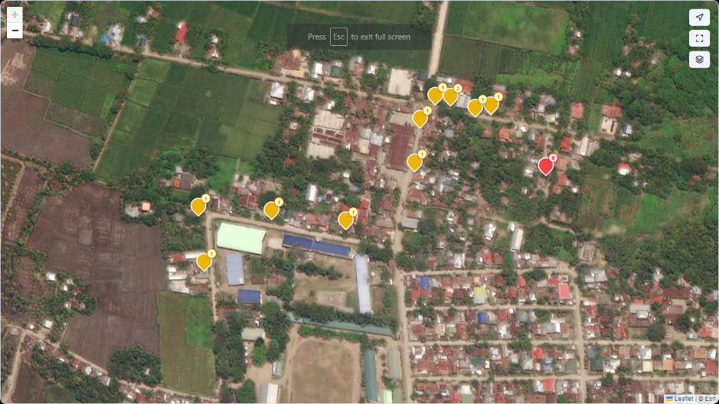
2. remove this or change this
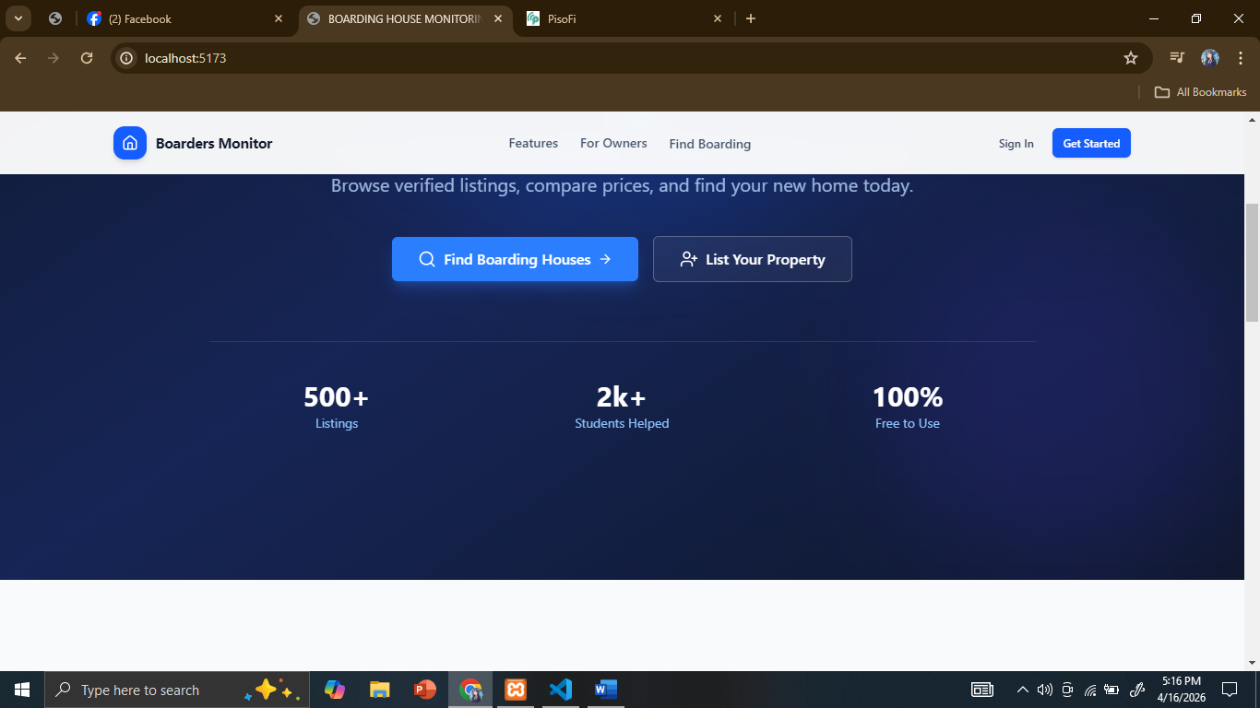
- Admin can reject and approve account of student and BH owner, and if Student/BHOwner’s account will be approve the notification of approval will be send through gmail of student/Owner. Dapat maka add ng pic si student and owner

- Student no change to student I’D
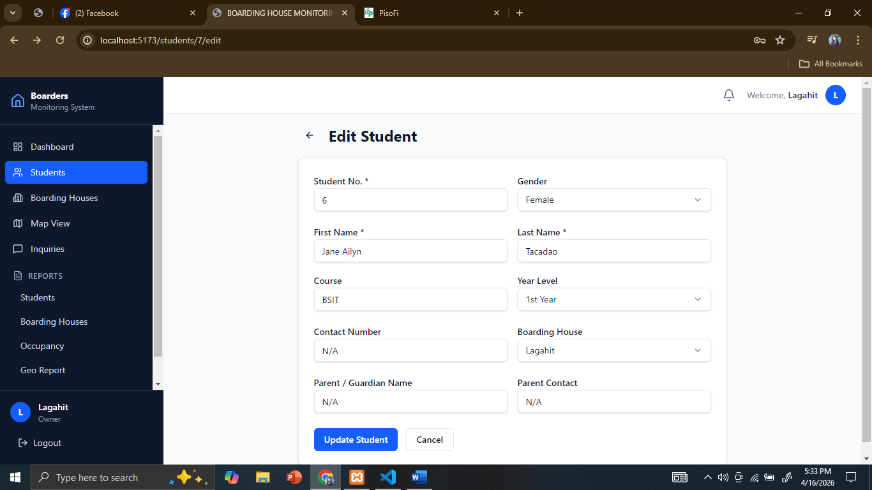
4.

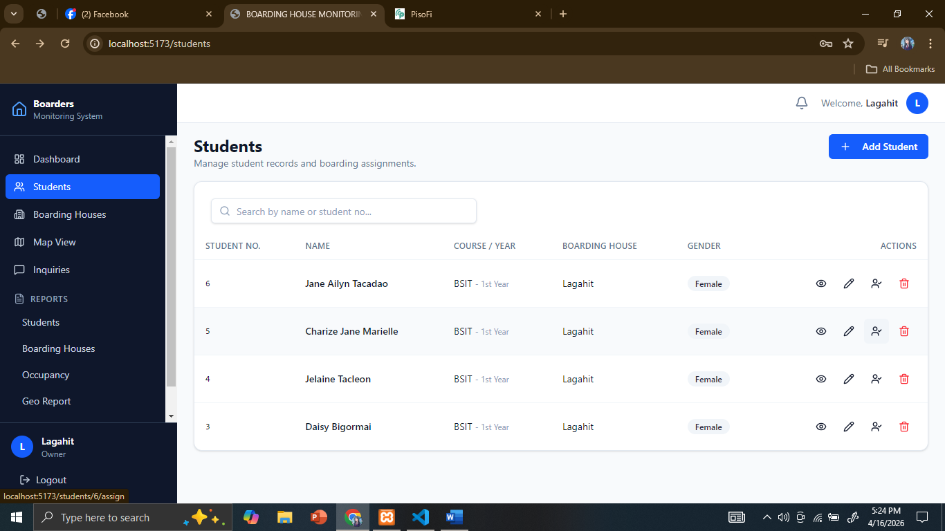
5. Dapat may assign room at assign BH (kasi si owner minsan ay may isa or dalawang bh) at hnd na maka add ng student if full na ang room

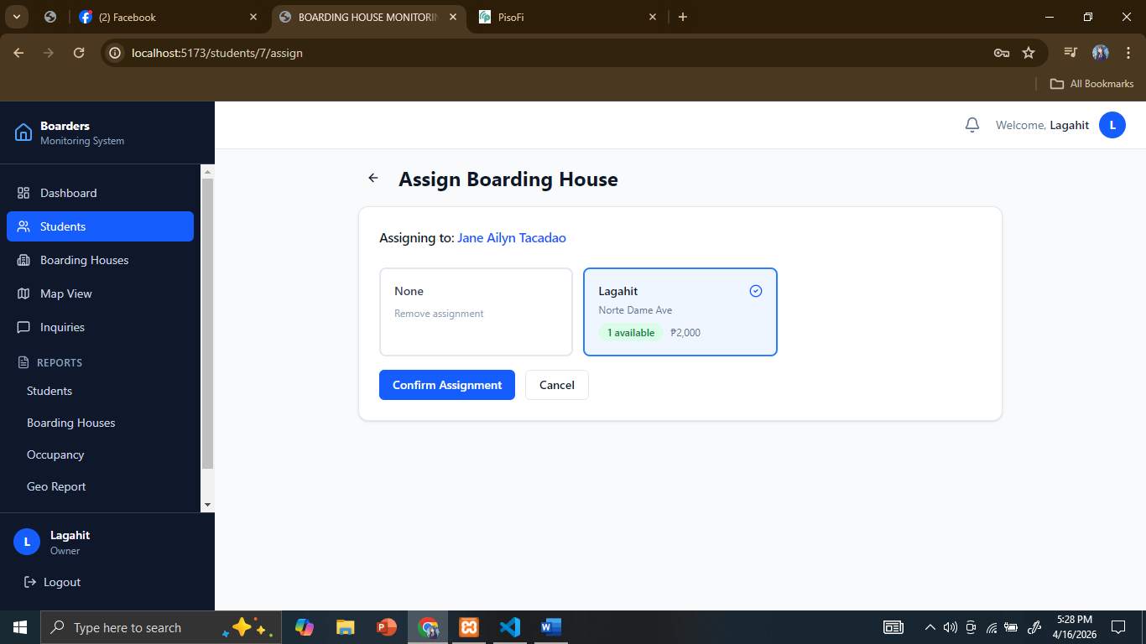

5. Send InQuiry change to Reservation
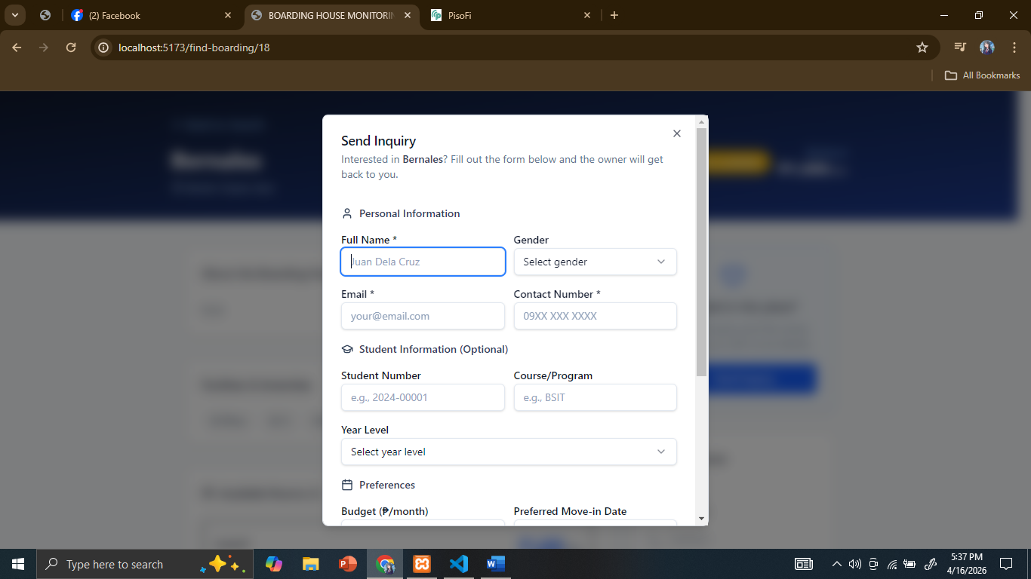
Dito is dapat auto detect na, for example no need nya na mag type ng information nya kasi once na na click na ni student yung reserve button makikita ito ni bh owner dahil ma auto detect na yung info sa account nya
And ang makikita lamang ni student sa reserve option is yung preferred move in date, year level, and Maka message ito kay owner
Wla ng preffered room option kasi nakita na ni student kung ano yung available room
at wala ng budget option kasi nakikita nani student ang price ng BH
and sa account ni student maka lagay sya ng address, para once nag reserve ng room si student is alam na ni bh owner kung taga saan sya

6. Dito ay dapat merong dalawang option mano manong add and direct add sa STUDENTS, direct add is for mga student na, na approved yung reservations
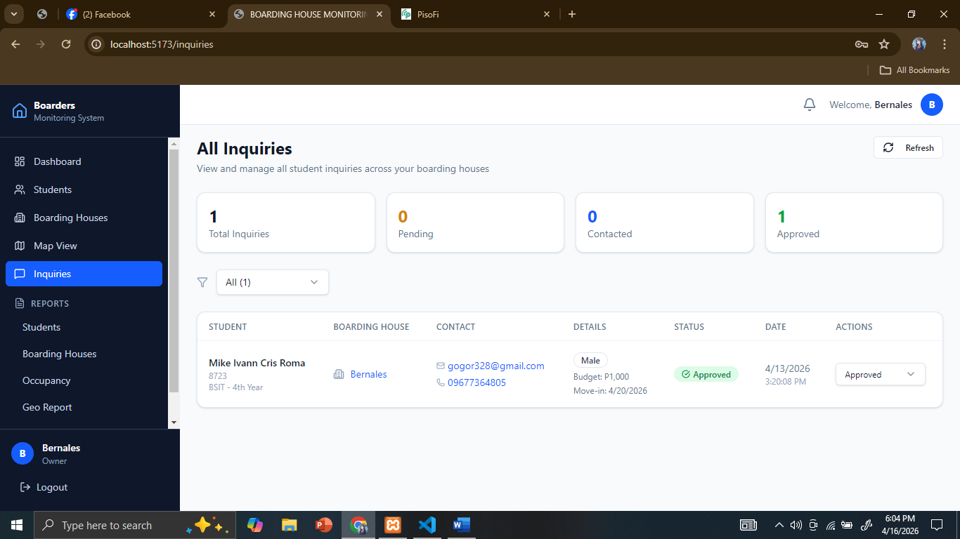

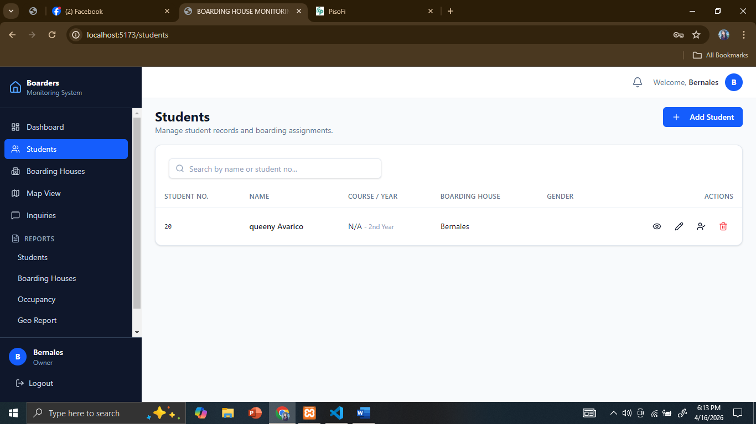

7. Kung mag add room si owner, need nya mag upload ng picture ng 3 picture ng room nya
8. Dapat wla na ito kasi understand na kasi ito na kay BH owner na Talaga itong BH ang hindi lang ma wala ay ang kay Admin kasi need nya makita kung saang BH si student.



9. Dapat hindi maka Edit and add room si admin ang kaya lang gawin ni admin is maka view and delete
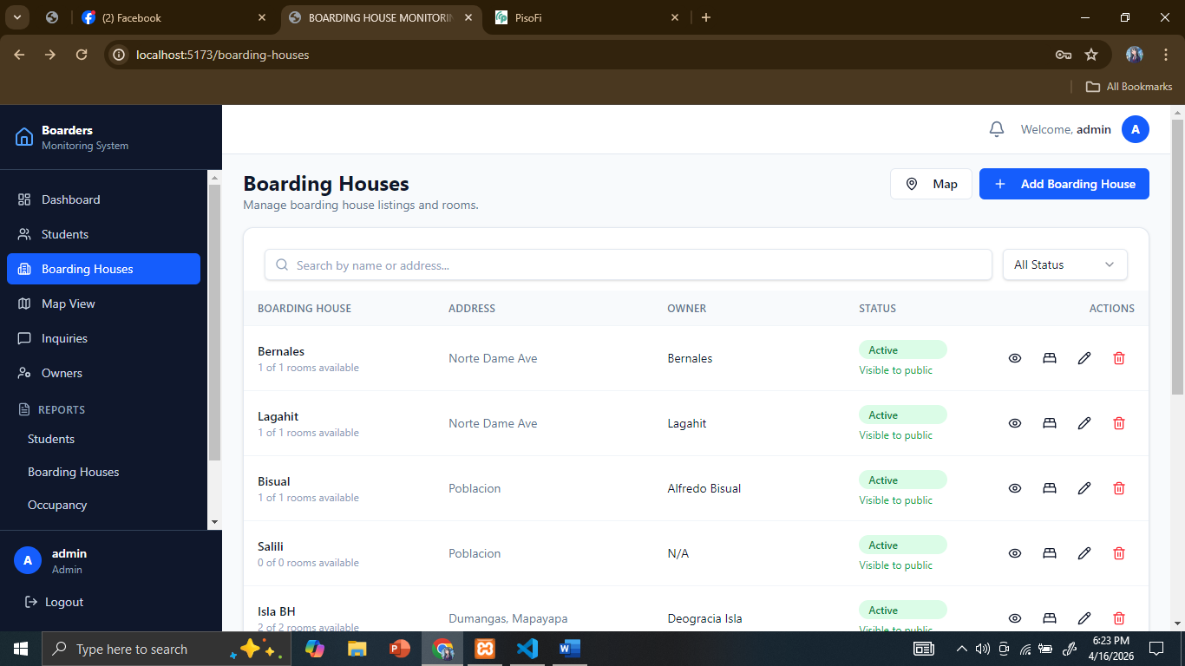

10. SA room dapat may action na [add student option], and hindi na ma click ang available and occupied kasi dapat naka auto detect na once meron ng student ang na add dito and hnd na maka add ng student sa room if full na
Dapat ang ma add na student sa room is within pila ka slots lang sa room, for example 3 slots lang, dapat 3 people lang ang ma add

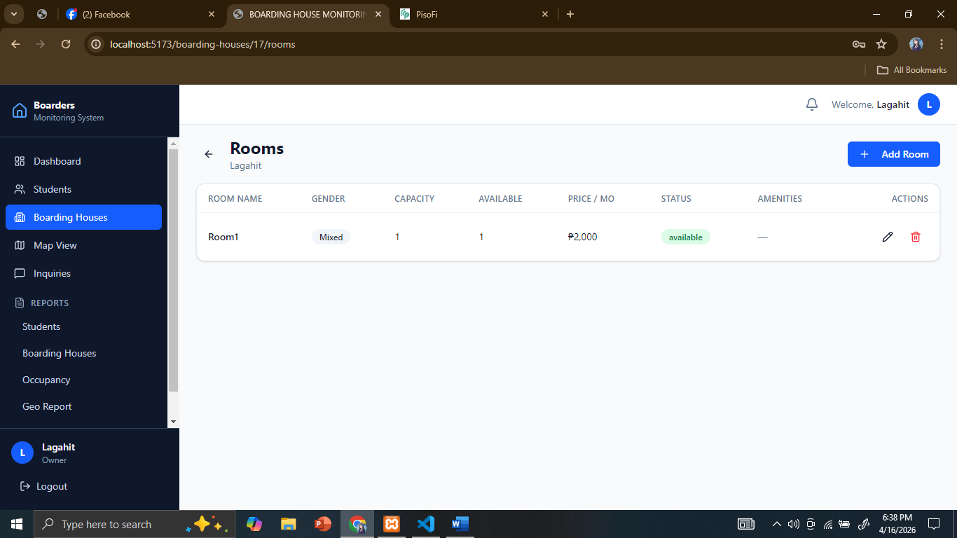
11. Backup and restore database

12. Public can view Boarding Houses in the map, but if they want to reserve boarding house They need to create/sign in.

13. pwede rin Seguro sud, na pweding makita ni Admin yung naka save na passwords ng account nila para no need na ng OTP (own opinion ko lang to kasi hindi ito gi add ni sir sa dapat e fix hahaha) at e send lang yung pass via email or contact number

14. Dapat na set eto sa SKSU Kalamansig Campus
